Directions: Draw the triangles with the given properties and solve for all missing side lengths and angle measures. The problems may have no solutions, one solution, or two solutions. If the problem has no solutions, write “No Solutions.” If a problem has two sets of solutions, be sure to include both. Round answers to the nearest hundredth.
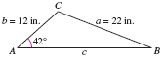
a = 15, b = 25, A = 85°

a = 12, b = 31, A = 20.5°

